Counter Culture Coffee processes customer payments for invoices by creating a Customer Payment record in NetSuite. Navigation Transactions > Customers > Accept Customer Payments.

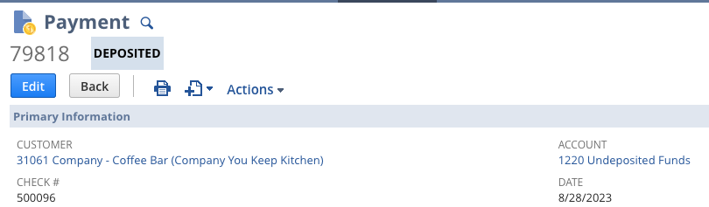

When they create this payment record, they select the invoices that this payment will be applied to. This can be one invoice or many invoices. 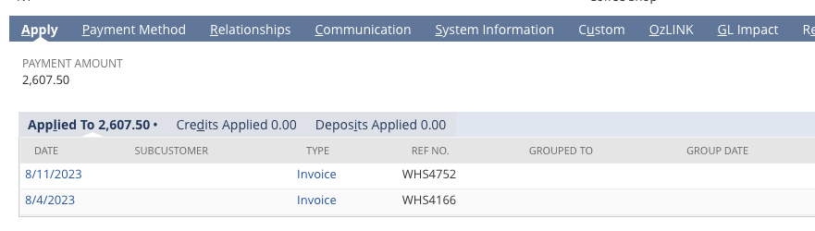

Under the Payment Method tab there is a field titled Payment Method.

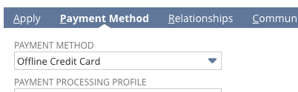

What needs to happen is if a Customer Payment record is created and saved or updated via the UI and the Payment Method field is populated with Offline Credit Card, then we need to check a box on the invoices associated with this customer payment record. These would be the same invoice records shown under the Applied To sub-tab in the screenshot above.

*** Note: When creating a customer payment record, there can be many invoices shown, but we only want to update the invoices that are selected.

Example: In the screenshot below I am creating a customer payment record and there are multiple invoices shown in the list for me to pay, but I only selected three of them. When I save the customer payment record, those are the three invoices that will be shown under the Applied To sub-tab and are the invoices that need to have the checkbox updated on.

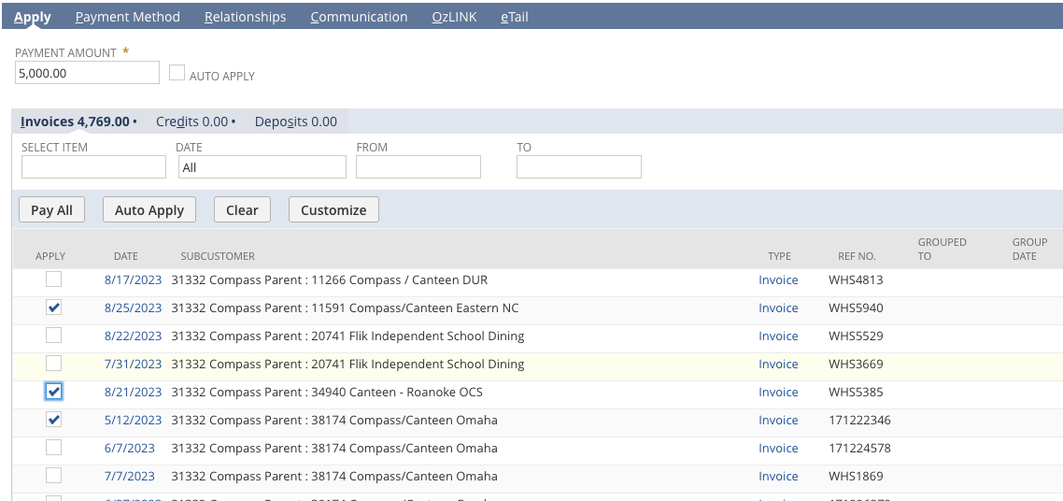

The custom field on the invoice is titled Paid in Shopify and the ID value is custbody_ccc_paid_shopify

So if a customer payment record is manually created or updated in NetSuite and the payment method is Offline Credit Card, the invoices that are associated with that customer payment record need to have the Paid in Shopify box checked.